Syllabus
Great Decisions 2013
PLS 495-Sections 003
UNCW
Lectures: Cameron Auditorium 105
Assigned Classes and Tutorial Leaders
Tuesdays and Thursdays - 7-8:45 pm

Instructor: Dr. Remonda Kleinberg
Office: Lakeside Hall 269
Telephone: (910) 962-4254
Office Hours: MW: 1-2pm or by appointment
Email: kleinbergr@uncw.edu
Please feel free to email me with concerns or questions.

Course Description: What Is Great Decisions?
Great Decisions (GD) promotes student awareness and discussion about timely foreign policy issues. Run by the Foreign Policy Association in New York, it is the oldest and largest grassroots educational program on world affairs of its kind in the country, with about 350,000 overall participants. Great Decisions is one of the five Flagship Programs of the World Affairs Councils of America. A Flagship Program is one that is broadly supported throughout the council system and that builds the name and impact of the system and its councils. Great Decisions celebrated its 50th anniversary in 2004. Councils around the country helped celebrate its tradition and history.
At UNCW, the purpose of Great Decisions is to educate all students from all Majors about issues of vital importance to American foreign policy, to provide you with the information to make informed decisions about the topics covered, and to be able to participate in the foreign-policy process. During the fall semester the student steering committee and course instructor, Dr. Kleinberg, work hard to find experts that can speak on the topics chosen by the Foreign Policy Association. Each year eight topics are chosen by a panel and in-depth articles on each subject are prepared by experts. The articles go into the 100-page softbound Great Decisions briefing book that appears with new content every January and will serve as your text for the course. Our speakers will give their own twist and focus to the topics at hand. This way you will have a good overview of the issues plaguing our globe presently.
The main requirements for making and keeping an A is to read your articles and attend tutorials and lectures listed below. All the lectures will take place at Cameron Auditorium on the designated dates. All tutorials will take place on Thursdays in your assigned classroom with student leaders to discuss topics related to the lectures, the readings and other international issues which may arise. It is all very informal and meant to enhance your understanding of the crucial global events facing us presently.
Please read the following meeting dates and places carefully. All meetings begin at 7 pm, so please be there between 6:30 and 7:00 to sign in and take your seat. Please note that attendance will be taken in both lectures and tutorials. Please keep laptops and electronic devices in your backpack or at home; any violation of this rule will lead to an exam given to the entire lecture at the end of the semester.
Grading: Students will be graded on attendance in both lectures and tutorials. Make sure to contact your Tutorial Assistant if any problems emerge to keep you from attending either session. You will be provided with all the contact information.
Course Text: Great Decisions 2013: You will find your text in the UNCW Bookstore, or buy a copy on-line. Other Sources include the Foreign Policy Association webpage: http://www.fpa.org/

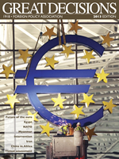

Grading Scheme: There are 18 meeting times throughout the semester including both lecture and tutorial: Each absence is the equivalent of minus half a grade: KEEP YOUR “A”!!!

Full Attendance and Participation = A
One Absence: = A-
Two Absences = B+
Three Absences = B
Four Absences = B-
Five Absences = C+
Six Absences = C
Seven Absences = C-
Eight Absences = D+
Nine Absences = D

Schedule of Lectures

Date: January 10: Introduction to Great Decisions Lecture Series and Kick-Off Lecture

Special Topic: The Nature and Politics of Human Intelligence
Guest: John O’Connell, Former Principal Deputy Director
National Counterterrorism Center

John "Geoff" O'Connell is currently a special advisor to the Office of the National Counterintelligence Executive. Mr. O’Connell was appointed as the National Counterterrorism Center's Principal Deputy Director in June 2008 where he served until 2011. He is a thirty-three year veteran of the CIA's National Clandestine Service where he spent the majority of his career in senior clandestine assignments overseas - most involving counterterrorism. Among his domestic assignments, he served as Deputy Chief of the FBI's International Terrorism Operations Section, Chief of CIA's Counterterrorist Center and Special Assistant to the Director of Central Intelligence for the Middle East Peace Process.

Mr. O'Connell is a graduate of Amherst College. He is the recipient of numerous domestic and foreign awards.

Date: January 15:
Topic: Egypt
Place: Cameron Auditorium
Guest: Mr. Gregory Aftandilian

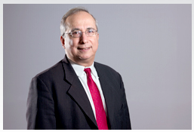

Mr. Gregory Aftandilian is an independent consultant, writer, and lecturer, having spent over 21 years in government service, most recently on Capitol Hill. He was foreign policy advisor to Congressman Chris Van Hollen (2007-08), professional staff member of the Senate Foreign Relations Committee and foreign policy adviser to Senator Paul Sarbanes (2000-04), and foreign policy fellow to Senator Edward Kennedy (1999). Prior to these positions, Mr. Aftandilian worked for 13 years as a Middle East analyst at the U.S. Department of State where he was a recipient of the Department’s Superior Honor Award for his analyses on Egypt. His other government experiences include analytical work for the U.S. Department of Defense and the Library of Congress. He was also a research fellow at the Kennedy School of Government at Harvard University (2006-07) and an International Affairs Fellow at the Council on Foreign Relations in New York (1991-92). In addition, Mr. Aftandilian has worked as a consultant on Egyptian affairs for the National Democratic Institute for International Affairs, and is an adjunct faculty member at Boston University and Northeastern University. Mr. Aftandilian is the author of Egypt’s Bid for Arab Leadership: Implications for U.S. Policy (1993); and Looking Forward: An Integrated Strategy for Supporting Democracy and Human Rights in Egypt (2009). Mr. Aftandilian holds a B.A. in history from Dartmouth College, an M.A. in Middle Eastern studies from the University of Chicago, and an M.S. in international relations from the London School of Economics.

Summary of Lecture

The popular revolution that ousted President Hosni Mubarak in 2011 ushered in the promise of radical change. Two years later, what is the state of Egyptian democracy? How will the military and the civilian government balance power?

January 17: Proceed to your tutorial

Date: January 22
Topic: NATO
Place: Cameron Auditorium
Guest: Stefano Santamato

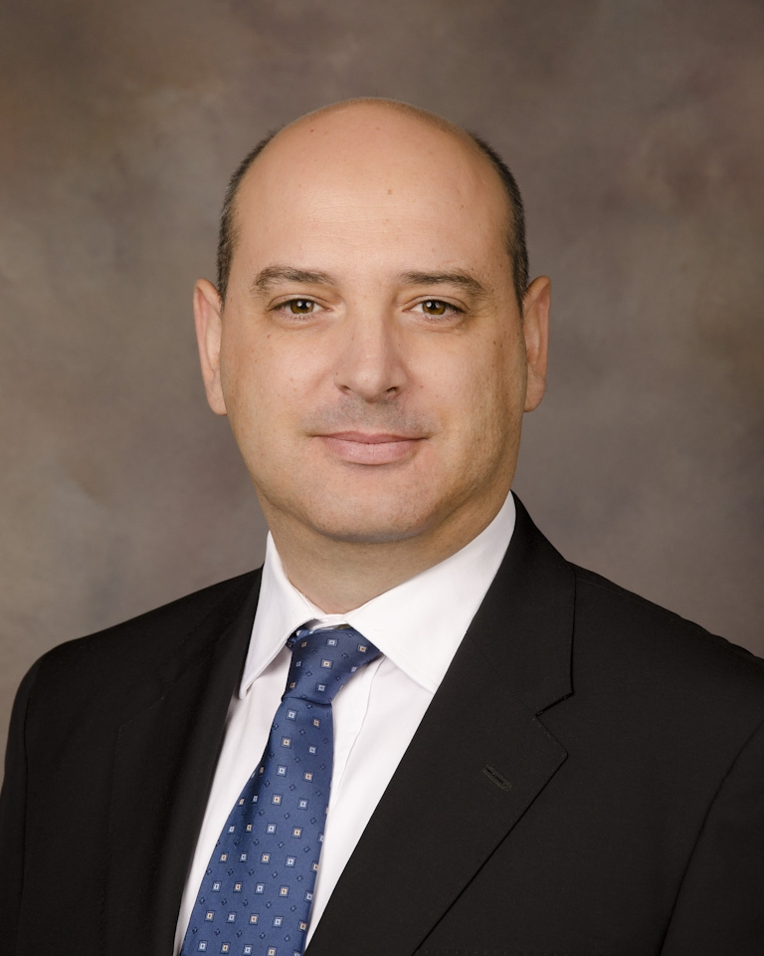

Stefano Santamato is a Senior Research Fellow for the Center for Transatlantic Security Studies (CTSS) at National Defense University’s Institute for National Strategic Studies (NDU-INSS). His work focuses on US-NATO relations through research, publications and education.
Stefano Santamato has a long-standing career at NATO, where he has served as the senior civilian staff officer in the Strategic Analysis Capability (SAC) and worked for the Operations Division, dealing with various aspects of crisis management and planning, respectively, in the Civil Emergency Planning and Crisis Management Planning sections.
Throughout his experience at NATO, Stefano Santamato has promoted an innovative and forward-looking approach to the Alliance’s crisis management. This includes the development of the concept for the Strategic Analysis Capability, a joint civil-military structure providing NATO’s Secretary General with comprehensive analysis in regards to potential and emerging crises, and of the COMPASS Database for the identification and use of civil experts in NATO planning and operations. Stefano Santamato joined NATO in 2000, as staff officer for the Military Common-funded Resource Policy Unit were he carried out analyses and assessments of NATO’s common-funded requirements. His international experience includes working for the European Commission where he has been in charge of identifying, preparing and overseeing various co-operation projects with Chile; and collaboration with the Directorate General for Research and Studies of the European Parliament. Stefano Santamato served in the Italian Air Force between 1993 and 1994. He is a graduate in Political Sciences and International Public Law at the University of Milan and holds a Master degree in International Politics.

Summary of Lecture: How has NATO’s agenda evolved since its inception during the cold war? With its military commitment in Afghanistan winding down and a recent successful campaign in Libya, what are the Alliance’s present-day security challenges?
January 24: Proceed to your tutorial
Date: January 29
Topic: Humanitarian Intervention
Place: Cameron Auditorium
Guest: Joel Voss.

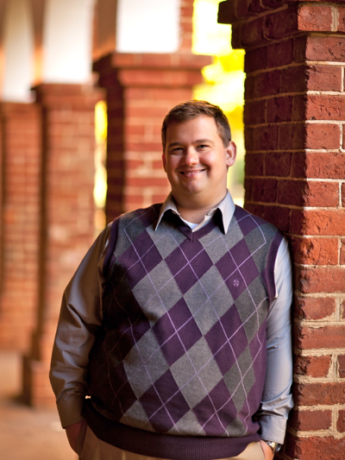

Joel Voss is a doctoral candidate in the Woodrow Wilson Department of Politics at the University of Virginia. He specializes in human rights (the philosophy of human rights, human rights law, quantitative methods in the study of human rights, and human rights advocacy. Joel focuses on humanitarian intervention and international conflict resolution as well as international relations.

Summary of Lecture

The “responsibility to protect” (R2P) doctrine has become central to modern humanitarian intervention. When should the international community intervene? Why did the West rush to intervene in Libya but not Syria?

January 31: Proceed to your tutorials

Date: February 5
Topic: Future of the Euro
Place: Cameron Auditorium
Guest: Dr. Clay Moffett

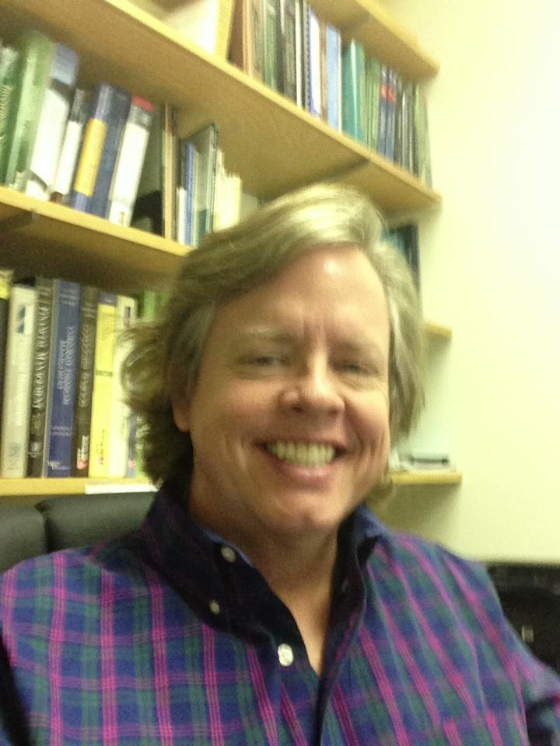

Dr. Moffett is co-advisor for the Financial Management Association and teaches derivatives and investment courses at the undergrad and graduate level. He currently serves on the Board of Directors for the Academy of Economics and Finance. His research interests are in the field of synthetic replication of shorted securities, derivative markets, market micro-structure and portfolio theory. He has served for over 20 years as a portfolio manager/trader, consultant to Fortune 100 companies and as the CFO of a regional publishing company.

Summary of Lecture

How did the 2008 global recession contribute to the development of the euro crisis? The health of the euro affects and is affected by the state of the global economy. How can European Union leaders prevent the collapse of the common currency?

February 7: Proceed to your tutorial

Date: February 12
Topic: Threat Assessment
Place: Cameron Auditorium 105
Guest: Dr David Schanzer
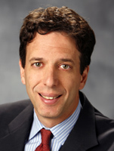
David Schanzer is an associate professor at Duke University and director of the Triangle Center on Terrorism and Homeland Security, a research consortium between Duke, UNC-Chapel Hill and RTI International. In these capacities, he teaches courses on counterterrorism strategy, counterterrorism law and homeland security. He also serves as the director for strategy and outreach for the Institute of Homeland Security Solutions, a North Carolina-based research consortium focused on applied social science research for homeland security. Dr. Schanzer is the lead author of a widely cited National Institute of Justice study on domestic radicalization – “Anti-Terror Lessons of Muslim Americans” (2010) – and a report on “Improving Strategic Risk Management at the Department of Homeland Security,” published by the IBM Center for the Business of Government. Prior to his academic appointments, Dr. Schanzer was the Democratic staff director for the House of Representatives Committee on Homeland Security from 2003 to 2005. He previously served as the legislative director for Sen. Jean Carnahan (2001-2002), counsel to Sen. Joseph R. Biden Jr. (1996-1998), and counsel to Sen. William S. Cohen (1994-1996). His positions in the executive branch include special counsel, Office of General Counsel, Department of Defense (1998-2001) and trial attorney, United States Department of Justice (1992-94. Dr. Schanzer is a graduate of Harvard College where he received an A.B. cum laude in government in 1985 and of Harvard Law School. Schanzer has appeared on international, national and local radio and television discussing terrorism and homeland security and is the author of more than 20 op-ed articles on these subjects that have appeared in newspapers around the country.
Summary of Lecture: How can the United States address the challenges of a weak economy, homegrown terrorism and nuclear proliferation? What threats and opportunities are presented by the ascendancy of China and by regime change in the Middle East.

February 14th: Proceed to your tutorial

Date: February 19
Topic: Iran
Place: Cameron Auditorium

Guest: Amb David Litt

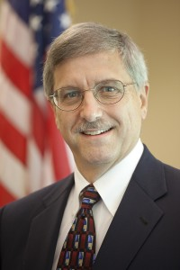

Ambassador Litt served for 34 years as a career U.S. diplomat, specializing in the Middle East and Southwest Asia. In 2005-2006 he was the third-ranking officer at the U.S. Embassy in Baghdad, Iraq, with the title of Political-Military Counselor, providing policy advice to the U.S. Ambassador, and serving as liaison between the Embassy and the Multi-National Forces – Iraq. While at the Department of State, Ambassador Litt served as the Director of the Office of Northern Gulf Affairs (Iran and Iraq), and also as Desk Officer for Saudi Arabia. In addition to a tour as economic/commercial officer in Kabul, Afghanistan, in the late 1970s, he served twice as political officer in Damascus, Syria. Just prior to his recent service in Baghdad, he was the State Department’s Diplomat-in-Residence at Duke University in Durham, North Carolina.
Presently, Ambassador David C. Litt is the Executive Director of the Center for Stabilization and Economic Reconstruction at the Institute for Defense and Business in Chapel Hill.

Summary of Lecture
Suspicion and a troubled history have blighted U.S.-Iranian relations for three decades. How can the United States and Iran move forward? Is the existence of Iran’s nuclear program an insurmountable obstacle?

February 21rd Proceed to tutorial
Date: February 26th
Topic: China in Africa
Place: Cameron Auditorium
Guest: Dr Paige Tan
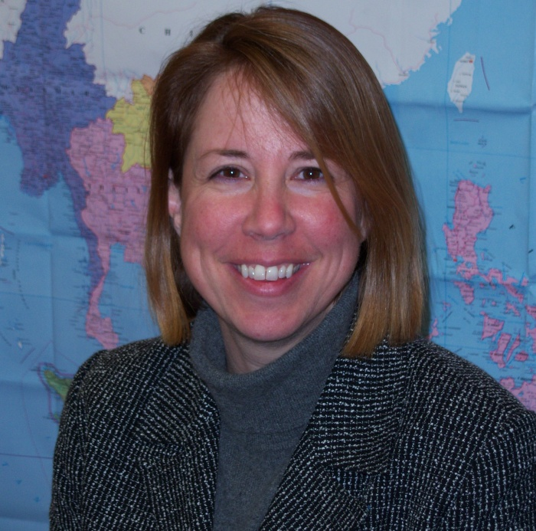
Paige Johnson Tan, Ph.D. is an Associate Professor of Political Science in the Department of Public and International Affairs at UNCW. She specializes in Asian Politics, with special focus on Indonesia, Singapore, China, and India. Her research focuses on political parties and their role in democratization. Her most recent book chapter focuses on anti-party attitudes in Indonesia, Philippines, and Thailand. Dr. Tan has contributed articles on Asian topics to academic journals Indonesia, Contemporary Southeast Asia, Education about Asia, Asian Perspective, and the Journal of Social Work in Disability and Rehabilitation as well as news outlets Jakarta Post, Daily Yomiuri (Japan), and Star News (Wilmington, NC). Dr. Tan has consulted on Asian/governance topics with Sea-Change Partners (Singapore), the Drug Enforcement Administration, the State Department (Washington, DC), the World Bank (Jakarta, Indonesia), and Military Civil Affairs (Fort Bragg, NC). Dr. Tan is also the Assistant Chair of the Department of Public and International Affairs at UNCW. Her Ph.D. is from the University of Virginia and her Master’s from the Monterey Institute of International Studies.

Summary of Lecture

What interests govern China’s engagement in Africa? Should China’s growing emphasis on political ties and natural resource extraction inform U.S. relations with African nations?

February 28: Proceed to your tutorial

March 3-10th – March Break!!

Date: March 12th
Topic: Myanmar and SE Asia
Place: Cameron Auditorium
Guest: Robert Nolan

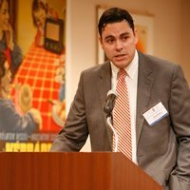

Robert Nolan is editor in chief of new media at the Foreign Policy Association, and producer of Great Decisions in Foreign Policy on PBS. He has written extensively on issues related to African politics and culture for publications including the Christian Science Monitor, the Village Voice, UN Wire and Global Rhythm world music magazine. A former Peace Corps volunteer in Zimbabwe and graduate of the Medill School of Journalism at Northwestern University, he has interviewed heads of state, foreign ministers, artists, musician and Nobel laureates.

Summary of Lecture:

The West has welcomed unprecedented democratic reforms made by Myanmar’s government. What challenges must Myanmar overcome before it can fully join the international community? What role can it play in Southeast Asia?

March 14th: Proceed to tutorials

Good luck with the rest of your semester!!

Tutorial Teams

Group One: Meets in Leutze Hall 111 – Code = 268

David Miller
dmm8883@uncw.edu,

Stephanie Pipkin
smp6068@uncw.edu

G1 | Student Name
1 | Ajizian, Christopher A.
2 | Allen, Matthew M.
3 | Allinson, Nicholas
4 | Austin, Daniel E.
5 | Ballard, Amy E.
6 | Barszcz, Dominic T.
7 | Belcher, Kara N.
8 | Benedict, Kyle D.
9 | Bennett, Dewey F.
10 | Bennett, Emma R.
11 | Bent, Maria Alexis M.
12 | Betner, Amanda M.
13 | Biddix, Sarah N.
14 | Bissette, Michael R.
15 | Bitting, Bill
16 | Blakeley, Leah K.
17 | Bohn, Alexandra R.
18 | Bolger, Andrew F.
19 | Bond, Robert M.

Group Two: Meets in Leutze Hall 131 – Code = 1492

Jeremiah Rowley
jr3314@uncw.edu

Samantha Duncan
srd8052@uncw.edu

G2 | Student Name
20 | Boyle, Logan P.
21 | Brady, Collin M.
22 | Brock, Hannah M.
23 | Brown, Kevin
24 | Buddenbaum, Jonathan C.
25 | Burk, Logan T.
26 | Caison, Bradley J.
27 | Cashwell, Jeffrey M.
28 | Chamberlain, Krielow
29 | Chiriboga, Ericka A.
30 | Collie, Kevin M.
31 | Collins, Tony
32 | Corn, Aliceann S.
33 | Corn, Casey T.
34 | Crowell, Benjamin M.
35 | Dale, Kara D.
36 | Daley, Diana C.
37 | Dalziel, Meghan
38 | Daniels, Michael J.

Group Three: Meets in Leutze Hall 136 – Code = 1492

Sarah Barnett
sab3000@uncw.edu

Kabir Syed
ks6921@uncw.edu

G3 | Student Name
39 | Davidson, Alex
40 | Dawson, Kelsey M.
41 | Deming, Madeline L.
42 | Dimon, Casey C.
43 | Dipietro, Angela D.
44 | Doiron, Chelsea R.
45 | Dokmanovich, Lovie A.
46 | Doubleday, Margaret A.
47 | Douglass, Abigail C.
48 | Dubinski, James R.
49 | Dunkin, Abby E.
50 | Edens, Michael T.
51 | Ehresmann, Harrison M.
52 | Ellis, James R.
53 | Elovsson, Christian M.
54 | Emanuels, Emily L.
55 | Fischer, Rebecca L.
56 | Fletcher, Amanda J.

Group Four: Meets in Leutze Hall 139 – Code =3456

Joseph Chambers
jwc8615@uncw.edu
Joseph Harris
jlh6528@uncw.edu

G4 | Student Name
57 | Franklin, William H.
58 | Gallagher, Cole D.
59 | Gates, Juliana F.
60 | Glowacki, Jacob L.
61 | Goldberg, Zachary D.
62 | Gombatz, Jordan R.
63 | Goodman, Tiffany L.
64 | Gorman, Claire M.
65 | Gough, Alysoun M.
66 | Gruenig, Seraina C.
67 | Guarisma, Angel N.
68 | Halstead, James A.
69 | Hamlin, Alyssa D.
70 | Hammonds, Samantha D.
71 | Hanrahan, Michaela
72 | Harberg, Wesley M.
73 | Harbold, Taylor A.
74 | Hardin, Ryan M.

Group Five: Meets in Leutze Hall 138 – Code = 1492

Austin Cloyed
agc5994@uncw.edu

Daphne Henning
sdh8814@uncw.edu

G5 | Student Name
75 | Harrell, Sarah E.
76 | Hawkins, Roman S.
77 | Hayes, Brian K.
78 | Henson, Sarah P.
79 | Hile, Destinee M.
80 | Hillen, Laurel S.
81 | Hines, Kramer C.
82 | Hinman, Holly A.
83 | Holder, Jade A.
84 | Hornick, Douglas A.
85 | Hudson, Robin L.
86 | Hutcherson, Michael J.
87 | Jerman, Darius J.
88 | Jones, Amos C.
89 | Jones, Garry L.
90 | Judge, Lindsey M.
91 | Kalencki, Matthew R.
92 | Kercher, Margaret H.

Group Six: Meets in Leutze Hall 130 – Code = 1492

William Taylor
wlt2880@uncw.edu

Kerry Guy
kg2487@uncw.edu

G6 | Student Name
93 | Khatib, Lieth O.
94 | Khatib, Subreen A.
95 | Kohrs, Aaron P.
96 | Krakowsky, Aurelie
97 | Lambert, Linwood A.
98 | Lampke, Peter D.
99 | Lomax, Andrew J.
100 | Long, Timothy A.
101 | Lunsford, James D.
102 | Lynch, Jacob M.
103 | Marinello, Trinidad M.
104 | Matula, Sarah A.
105 | McCallop, Jessica S.
106 | McCulley, Andrew J.
107 | Medani, Mohamed A.
108 | Metcalfe, Tara L.
109 | Montoya, Priscila E.
110 | Morgan, Georgia L.
111 | Morris, Kristin R.

Group Seven: Meets in Leutze Hall 107– Code =1492

Blake Thompson
rbt2466@uncw.edu

Ali Parker
acp4667@uncw.edu

G7 | Student Name
112 | Motyka, Nicholas T.
113 | Murray, Emily B.
114 | Murray, Nina L.
115 | Myles, Ashley E.
116 | Newman, Bradley E.
117 | Norman, Lorah R.
118 | Norment, Nicholas W.
119 | Northey, Devin L.
120 | Notarangelo, Michael A.
121 | O'Quinn, Virginia H.
122 | O'Toole, Jenni M.
123 | Oberst, Matthew A.
124 | Oviedo, Maria A.
125 | Oyaneder, Bianca A.
126 | Palmer, Stephen J.
128 | Patel, Sweta B.
129 | Perez, Christopher D.
130 | Phan, Annie T.
131 | Pittman, Keith D.

Group Eight: Meets in Leutze 132 – Code = 3456

Craig Yarboro
lcy4224@uncw.edu

Keyln Brame
kmb5248@uncw.edu

G8 | Student Name
132 | Ponton, Noah W.
133 | Powell, Robert K.
134 | Roberts, Eryn A.
135 | Robertson, Matthew C.
136 | Rucker, Sarah J.
137 | Ruehle, Marissa L.
138 | Ruffin, Rachel C.
139 | Savage, Zeinab V.
140 | Shannon, Felicia R.
141 | Slyman, Mackenzie T.
142 | Smith, Lauren P.
143 | Smith, Sangjin K.
144 | Speight, Marks M.
145 | St Laurent, Benjamin
146 | Stallings, Jordan P.
147 | Stewart, Grant E.
148 | Stutts, William D.
149 | Synger, Ashley N.
150 | Tarlini, Miranda T.

Group Nine: Meets in Leutze Hall 104; Code 1492

Michael Dinunzio
fmd8360@uncw.edu

William Maxwell
wdm5448@uncw.edu

G9 | Student Name
151 | Taylor, David K.
152 | Taylor, Graham D.
153 | Taylor, Tate W.
154 | Terry, Kevin B.
155 | Tremblay, John T.
156 | Vergara, Lourdes A.
157 | Viguers, Caroline T.
158 | Vongprachanh, Diana
159 | Vorderkunz, Jessica L.
160 | Wade, Christopher M.
161 | Waegerle, Rebecca D.
162 | Welborn, Cary A.
163 | West, Nicole L.
164 | White, Weston K.
165 | Whiting, Jonathan A.
166 | Wissbaum, Brandon M.
167 | Wolfe, Kyle S.
168 | Young, Dane P.

Spring 2013 Academic Calendar

Registration and SeaNet dates–Please refer to the Calendar of Events at www.uncw.edu/reg/
New student orientation–Please refer to the Transition Programs at www.uncw.edu/orientation
January 8, Sunday | On-campus housing opens
January 9, Monday | Spring semester begins
January7-8, Monday-Tuesday | Orientation and advising
January 9, Wednesday | Classes begin
January 21, Monday | Martin Luther King State holiday; No classes
January 16, Wednesday | Last day for registration/Last day to drop (without a grade) or add a class. Tuition/fee payment after this date will be subject to a late payment charge. Last day to drop (without a grade) or add a class that meets Monday-only is January 24.
February 27, Tuesday | Last day to withdraw with W—undergraduate students
March 2, Saturday | On-campus housing closes 10 a.m.
March 3-10, Saturday-Sunday | No classes
March 10, Sunday | On-campus housing opens 10 a.m.
March 11, Monday | Classes resume 8 a.m.
March 28, Thursday | No classes
March 29, Friday | Good Friday State Holiday, No classes
April 1, Monday | Classes resume
April 26, Friday | Classes End
April 29, Monday | Final Examinations
April 30, Tuesday | Final Examinations
May 1, Wednesday | Final Examinations

